8/15/2026
LAB NO 06
Operating System Lab
Instructor: Ms. Muneeba Banaras
Submitted By: Wasif Ali
Reg ID: 245187
Class: BSCS F’24 B

LAB TASK
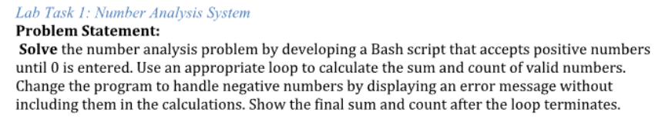
Code:
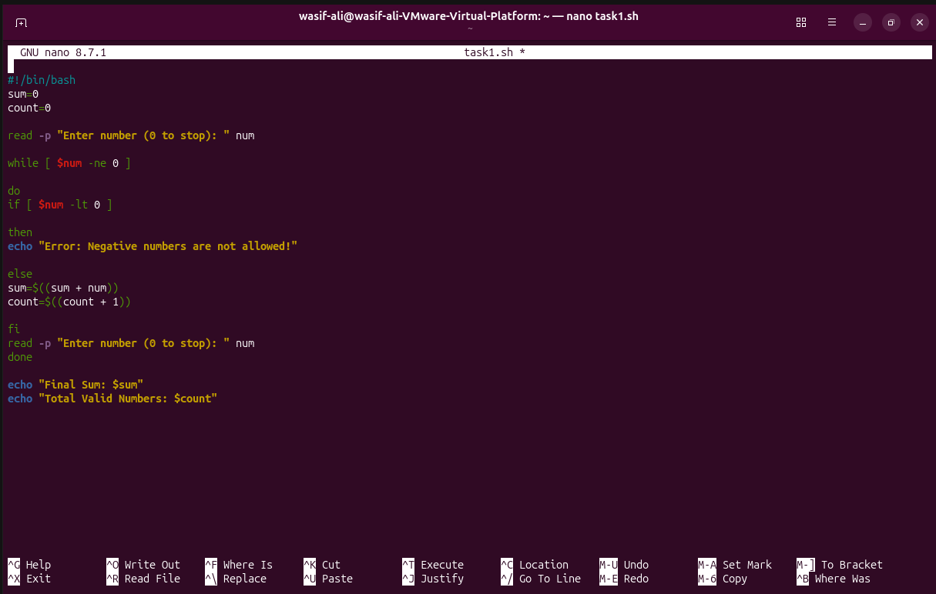
Result:
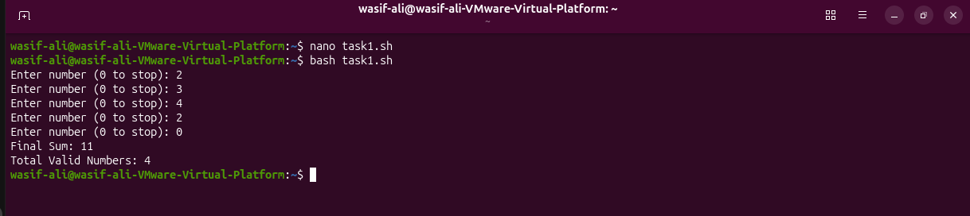
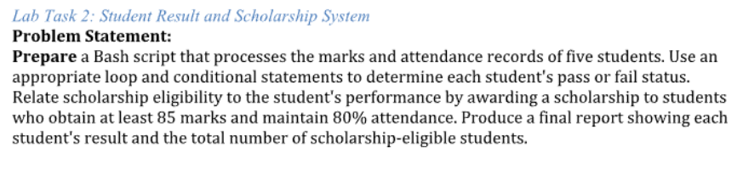
Code:
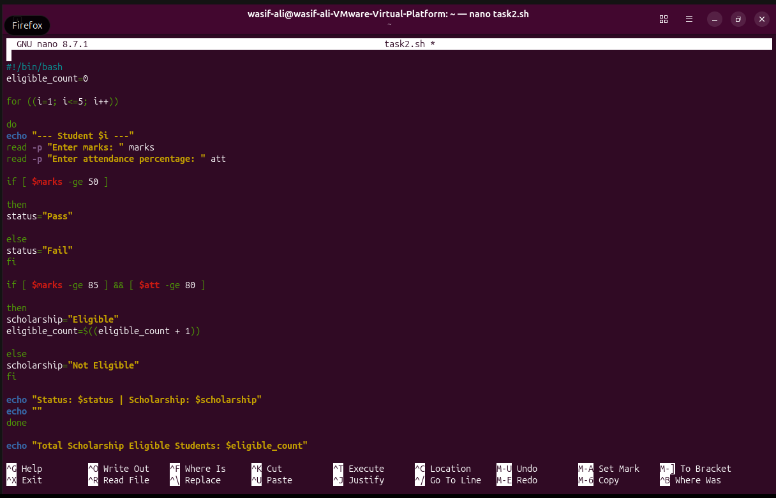

Commands:
